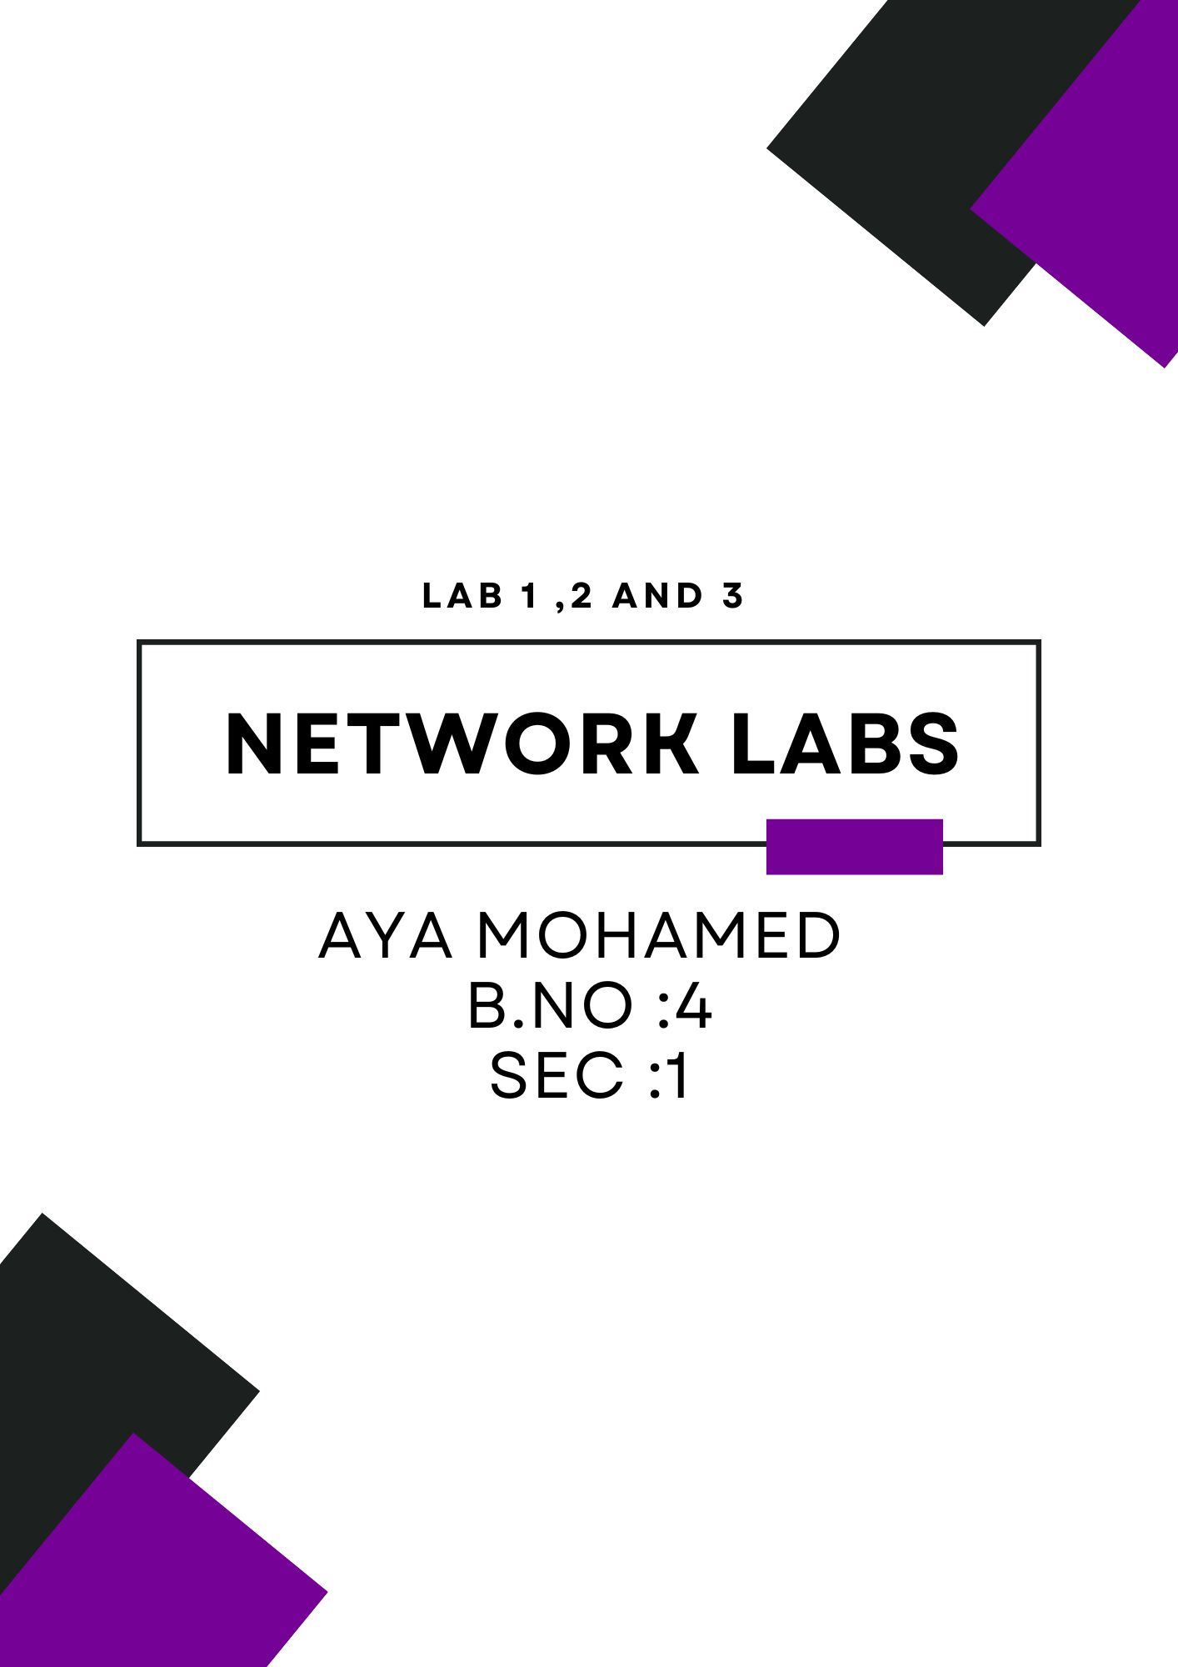
––––––
Wire Shark Labs Solutions for LAB 1 ,2 &3

LAB 1 Wireshark Lab: HTTP v7.0
In this lab, we’ll explore several aspects of the HTTP protocol:
- the basic GET/response interaction,
- HTTP message formats
- retrieving large HTML files
- retrieving HTML files with embedded objects
- HTTP authentication and security.
1. The Basic HTTP GET/response interaction

Open the file and get The response

Q1:Is your browser running HTTP version 1.0 or 1.1? What version of HTTP is the server running?
Answer: HTTP version is 1.1 @ the screen

Q2: What languages (if any) does your browser indicate that it can accept to the server?
Answer: The accepted language is en-US

Q3: What is the IP address of your computer? Of the gaia.cs.umass.edu server?
Answer:
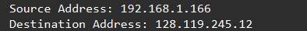

Q4: What is the status code returned from the server to your browser?

Answer: 200 is the status code returned

Q5: When was the HTML file that you are retrieving last modified at the server?
Answer:

Q6: How many bytes of content are being returned to your browser?
Answer: 128 bytes of content
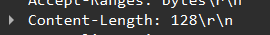

Q7: By inspecting the raw data in the packet content window, do you see any headers within the data that are not displayed in the packet-listing window? If so, name one.
Answer: yes as Server header

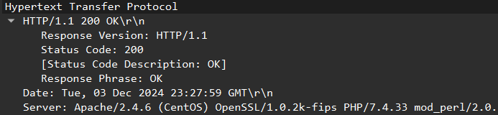

2.The HTTP CONDITIONAL GET/response interaction

Q8 &&&& Q10: Inspect the contents of the first HTTP GET request from your browser to the server. Do you see an “IF-MODIFIED-SINCE” line in the HTTP GET?.
Q10 Now inspect the contents of the second HTTP GET request from your browser to the server. Do you see an “IF-MODIFIED-SINCE:” line in the HTTP GET? If so, what information follows the “IF-MODIFIED-SINCE:” header?
Answer: first time there isn't IF-Modified-since because the cache is empty but when refresh the website it appears
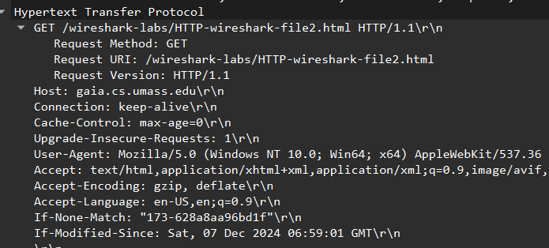

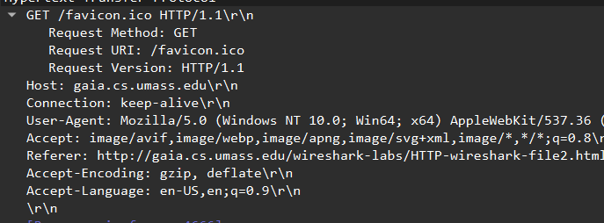

Q9 : . Inspect the contents of the server response. Did the server explicitly return the contents of the file? How can you tell?

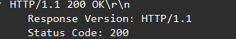
Answer: yes the server sent the file as the source code appear 200 OK

Q11: . What is the HTTP status code and phrase returned from the server in response to this second HTTP GET? Did the server explicitly return the contents of the file? Explain.

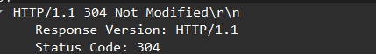
Answer: no server not sent the file again as the source code appear not modified 304

3. Retrieving Long Documents

Q12: How many HTTP GET request messages did your browser send? Which packet number in the trace contains the GET message for the Bill or Rights?

Answer: one Get request because the cache is empty & the no.of the packet is 1848 with the url in the image

Q13: Which packet number in the trace contains the status code and phrase associated with the response to the HTTP GET request?

Q14: What is the status code and phrase in the response?
Answer: packet number is 1913 and status code is 200OK
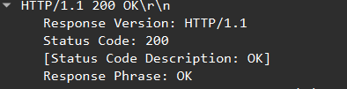
Q15: How many data-containing TCP segments were needed to carry the single HTTP response and the text of the Bill of Rights?
Answer: 3 TCP segments
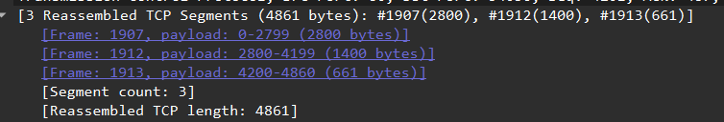
4. HTML Documents with Embedded Objects
Q16: How many HTTP GET request messages did your browser send? To which Internet addresses were these GET requests sent?
Answer: 2 get request
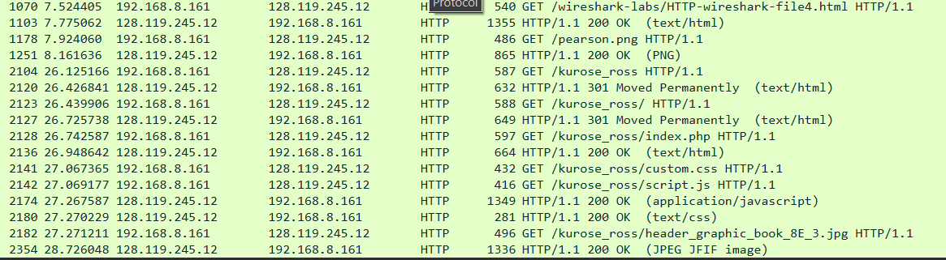

Q17: Can you tell whether your browser downloaded the two images serially, or whether they were downloaded from the two web sites in parallel? Explain.
Answer:
Based on the screen mentioned, if the HTTP GET requests for the images appeared at different times, it indicates that the browser downloaded the images serially rather than in parallel.

5 .HTTP Authentication

Q18: What is the server’s response (status code and phrase) in response to the initial HTTP GET message from your browser?
Answer:
The response is to be 401 Unauthorized, which means the server is requesting authentication or login before allowing access to the content.

Q19: . When your browser’s sends the HTTP GET message for the second time, what new field is included in the HTTP GET message?
Answer: It will send another request with an Authorization header that includes the username and password.

Lab2 :Wireshark Lab: ICMP v7.0
1. ICMP and Ping
Q1: What is the IP address of your host? What is the IP address of the destination host?
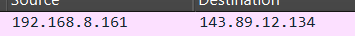
Answer: ip source is 192.168.8.161 & destination is 143.89.12.134

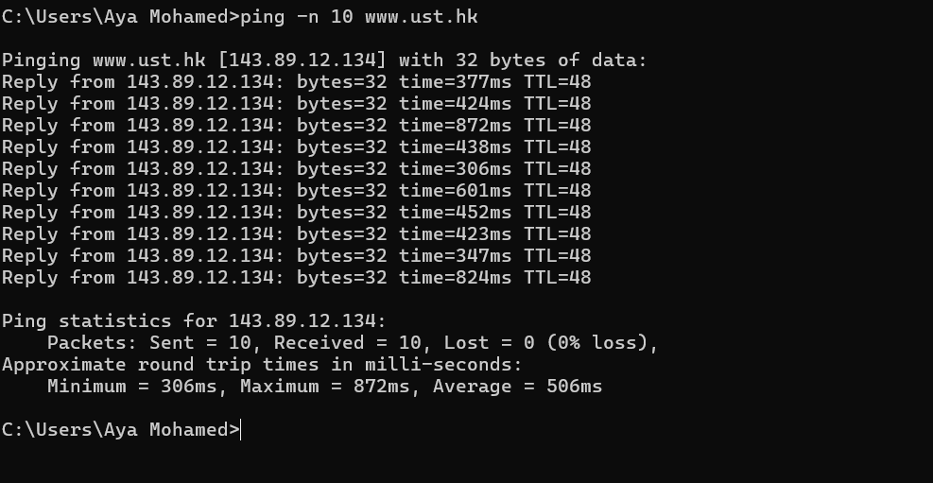

Q2: Why is it that an ICMP packet does not have source and destination port numbers?
Answer:
ICMP does not require ports because it operates at the Network Layer, not the Transport Layer. Protocols like TCP and UDP use port numbers to identify which service or application is handling the communication. On the other hand, ICMP uses only its fields like type and code to determine the message type (e.g., Ping request or reply).
Q3: Examine one of the ping request packets sent by your host. What are the ICMP type and code numbers? What other fields does this ICMP packet have? How many bytes are the checksum, sequence number and identifier fields?
Answer:
- Type: 8
- code: 0
- Checksum: This is used to verify the integrity of the data.
- Identifier: This helps distinguish between different requests.
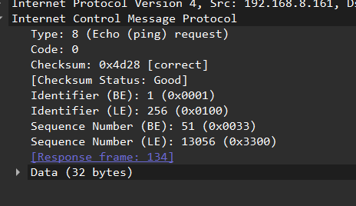
- Sequence Number: This keeps track of the packet order.

Q4: Examine the corresponding ping reply packet. What are the ICMP type and code numbers? What other fields does this ICMP packet have? How many bytes are the checksum, sequence number and identifier fields?
Answer:
- Type: 8
- code: 0
- Checksum: This is used to verify the integrity of the data.
- Identifier: This helps distinguish between different requests.
- Sequence Number: This keeps track of the packet order.
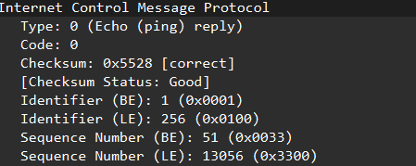

2. ICMP and Traceroute
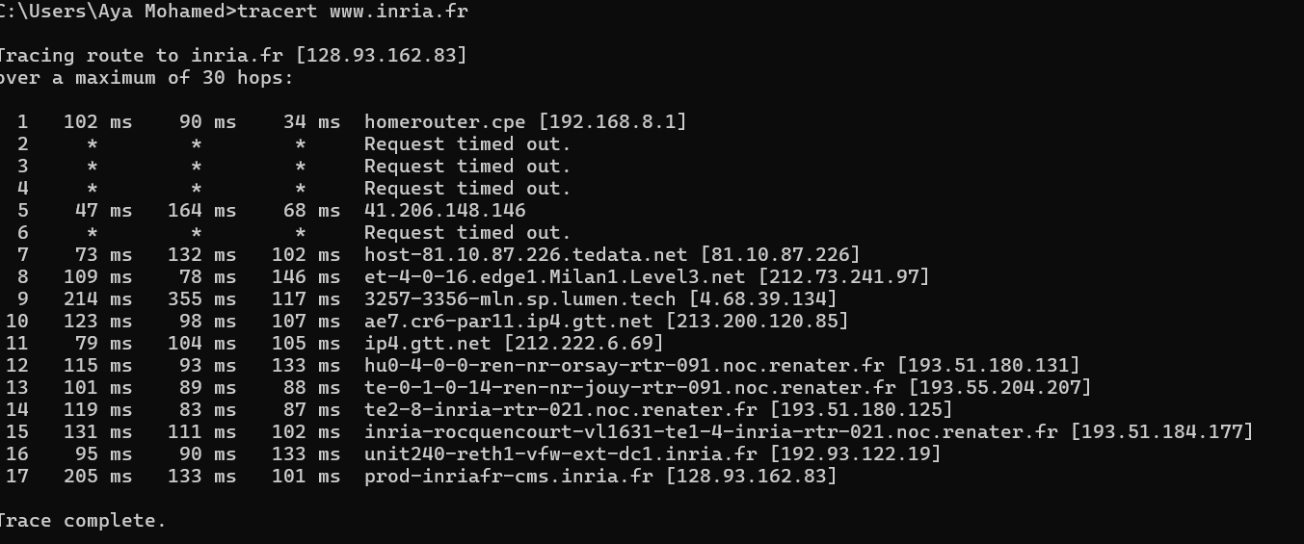
Q1: What is the IP address of your host? What is the IP address of the target destination host?
Answer:
Source address is 182.168.18.1
And Destination address is 128.93.162.83
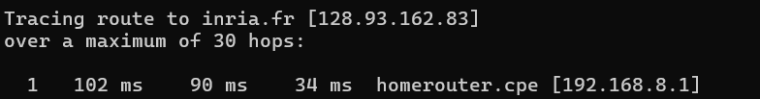
Q2: If ICMP sent UDP packets instead (as in Unix/Linux), would the IP protocol number still be 01 for the probe packets? If not, what would it be?
Answer: ICMP uses the protocol number 01 in the IP header. However, in Unix/Linux, the Traceroute program uses UDP packets instead of ICMP.
If UDP is used, the IP protocol number would not be 01. Instead, it would be 17, as 17 is the protocol number assigned to UDP in the IP header.

Q3: Examine the ICMP echo packet in your screenshot. Is this different from the ICMP ping query packets in the first half of this lab? If yes, how so?
Answer: Yes, the ICMP echo packet in the traceroute differs from the ICMP ping query packets in the first half of the lab. Here are the key differences:

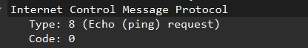

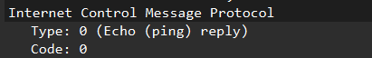

Echo request type :8
Echo reply type:0
Q4: Examine the ICMP error packet in your screenshot. It has more fields than the ICMP echo packet. What is included in those fields?
Answer: 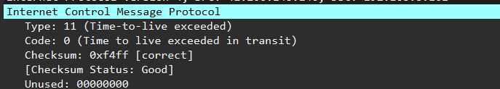

Lab3: Wireshark Lab: Ethernet and ARP
1.Capturing and analyzing Ethernet frames
Q1: What is the 48-bit Ethernet address of your computer?
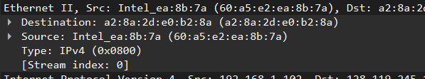
Q2: What is the 48-bit destination address in the Ethernet frame
Answer:

Q3: Give the hexadecimal value for the two-byte Frame type field. What upper layer protocol does this correspond to?
Answer: 0x0800 @ screen
Q4: How many bytes from the very start of the Ethernet frame does the ASCII “G” in “GET” appear in the Ethernet frame?
Answer: the total bytes up to the point before the HTTP GET message is:
- Ethernet Header: 14 bytes
- IP Header: 20 bytes
- TCP Header: 20 bytes
Total bytes so far = 14 + 20 + 20 = 54 bytes

Q5: What is the value of the Ethernet source address?
Q6: What is the destination address in the Ethernet frame? Is this the Ethernet address of your computer?
Yes the destination address is my comp.address
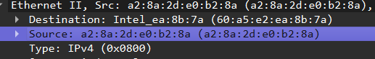
Answer:

Q7: Give the hexadecimal value for the two-byte Frame type field. What upper layer protocol does this correspond to?
Answer: 0x0800 IPv4
Q8: How many bytes from the very start of the Ethernet frame does the ASCII “O” in “OK” (i.e., the HTTP response code) appear in the Ethernet frame?
Answer:
the total bytes up to the point before the HTTP OK message is:
- Ethernet Header: 14 bytes
- IP Header: 20 bytes
- TCP Header: 20 bytes
Total bytes so far = 14 + 20 + 20 = 54 bytes

2. The Address Resolution Protocol
Q9: Write down the contents of your computer’s ARP cache. What is the meaning of each column value?
Answer:
• First column (Internet Address): This is the IP address.
• Second column (Physical Address): This is the MAC address.
• Third column (Type): This indicates whether the address was stored automatically (dynamic) or manually (static).

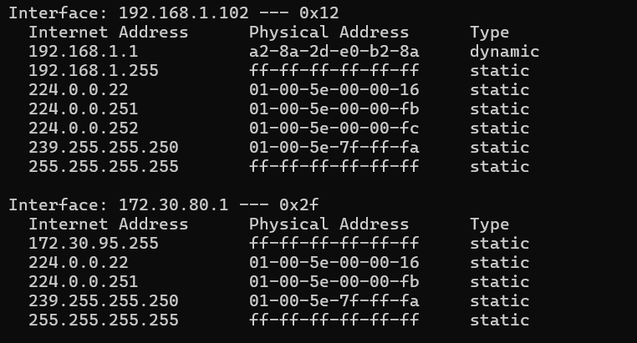

Observing ARP in action
Q10: Write down the contents of your computer’s ARP cache. What is the meaning of each column value?
Answer:
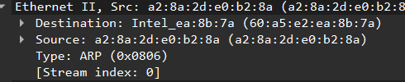
Q11: Give the hexadecimal value for the two-byte Ethernet Frame type field. What upper layer protocol does this correspond to?
Answer:0x0806

Q12:
- How many bytes from the very beginning of the Ethernet frame does the ARP opcode field begin?
Answer: We start with the Ethernet header (14 bytes), then add 20 bytes for the ARP header. So, the opcode field will start from byte 22 from the beginning of the Ethernet frame.
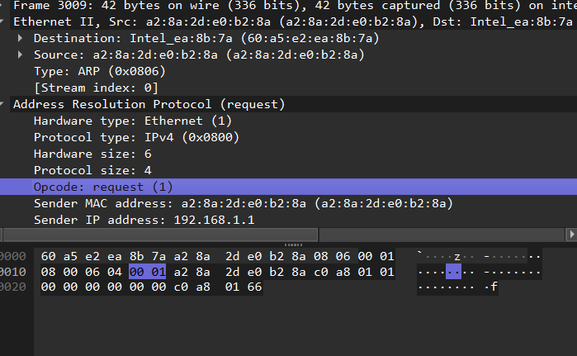

- What is the value of the opcode field within the ARP-payload part of the Ethernet frame in which an ARP request is made?
Answer: 1 request

- Does the ARP message contain the IP address of the sender?
d) Where in the ARP request does the “question” appear – the Ethernet address of the machine whose corresponding IP address is being queried?
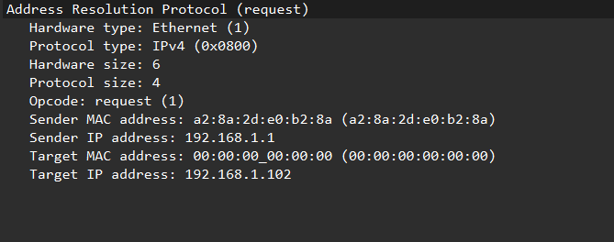
Answer:

Answer:

Q13: Now find the ARP reply that was sent in response to the ARP request.
- How many bytes from the very beginning of the Ethernet frame does the ARP opcode field begin?
Answer: The opcode field appears after the Ethernet header (14 bytes) and the ARP header. The ARP header is 28 bytes long, so the opcode field appears at byte 42 from the start of the Ethernet frame (14 bytes + 28 bytes).

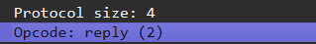
- What is the value of the opcode field within the ARP-payload part of the Ethernet frame in which an ARP response is made?
Answer:

c) Where in the ARP message does the “answer” to the earlier ARP request appear – the IP address of the machine having the Ethernet address whose corresponding IP address is being queried?
Answer:
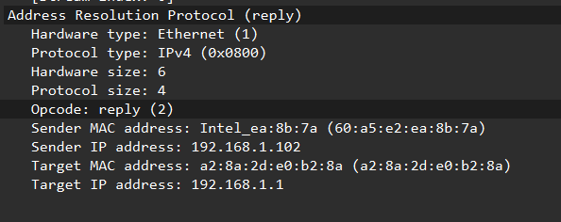

Q14: What are the hexadecimal values for the source and destination addresses in the Ethernet frame containing the ARP reply message?
Answer: